Experiment:4
Aim:
To write a Python program to solve a crypt-arithmetic problem in which each letter represents a unique digit.
Algorithm:
  - Start the program.
  - Import the permutations function from the itertools module.
  - Store the unique letters of the words in a string.
  - Generate different digit combinations from 0 to 9.
  - Assign a unique digit to each letter.
  - Check that the first letters S and M are not zero.
  - Convert the words SEND, MORE, and MONEY into numbers.
  - Check whether SEND + MORE = MONEY.
  - If the equation is true, print the solution and stop.
  - End the program.
Code:
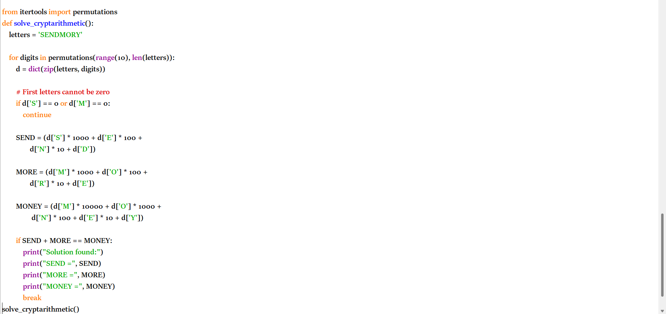
Output:
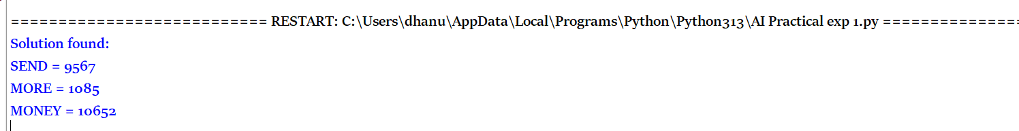
Result:
Thus the python program to solve the cryptarithmetic has been executed successfully.

